Two Factor Authentication

Flowchart
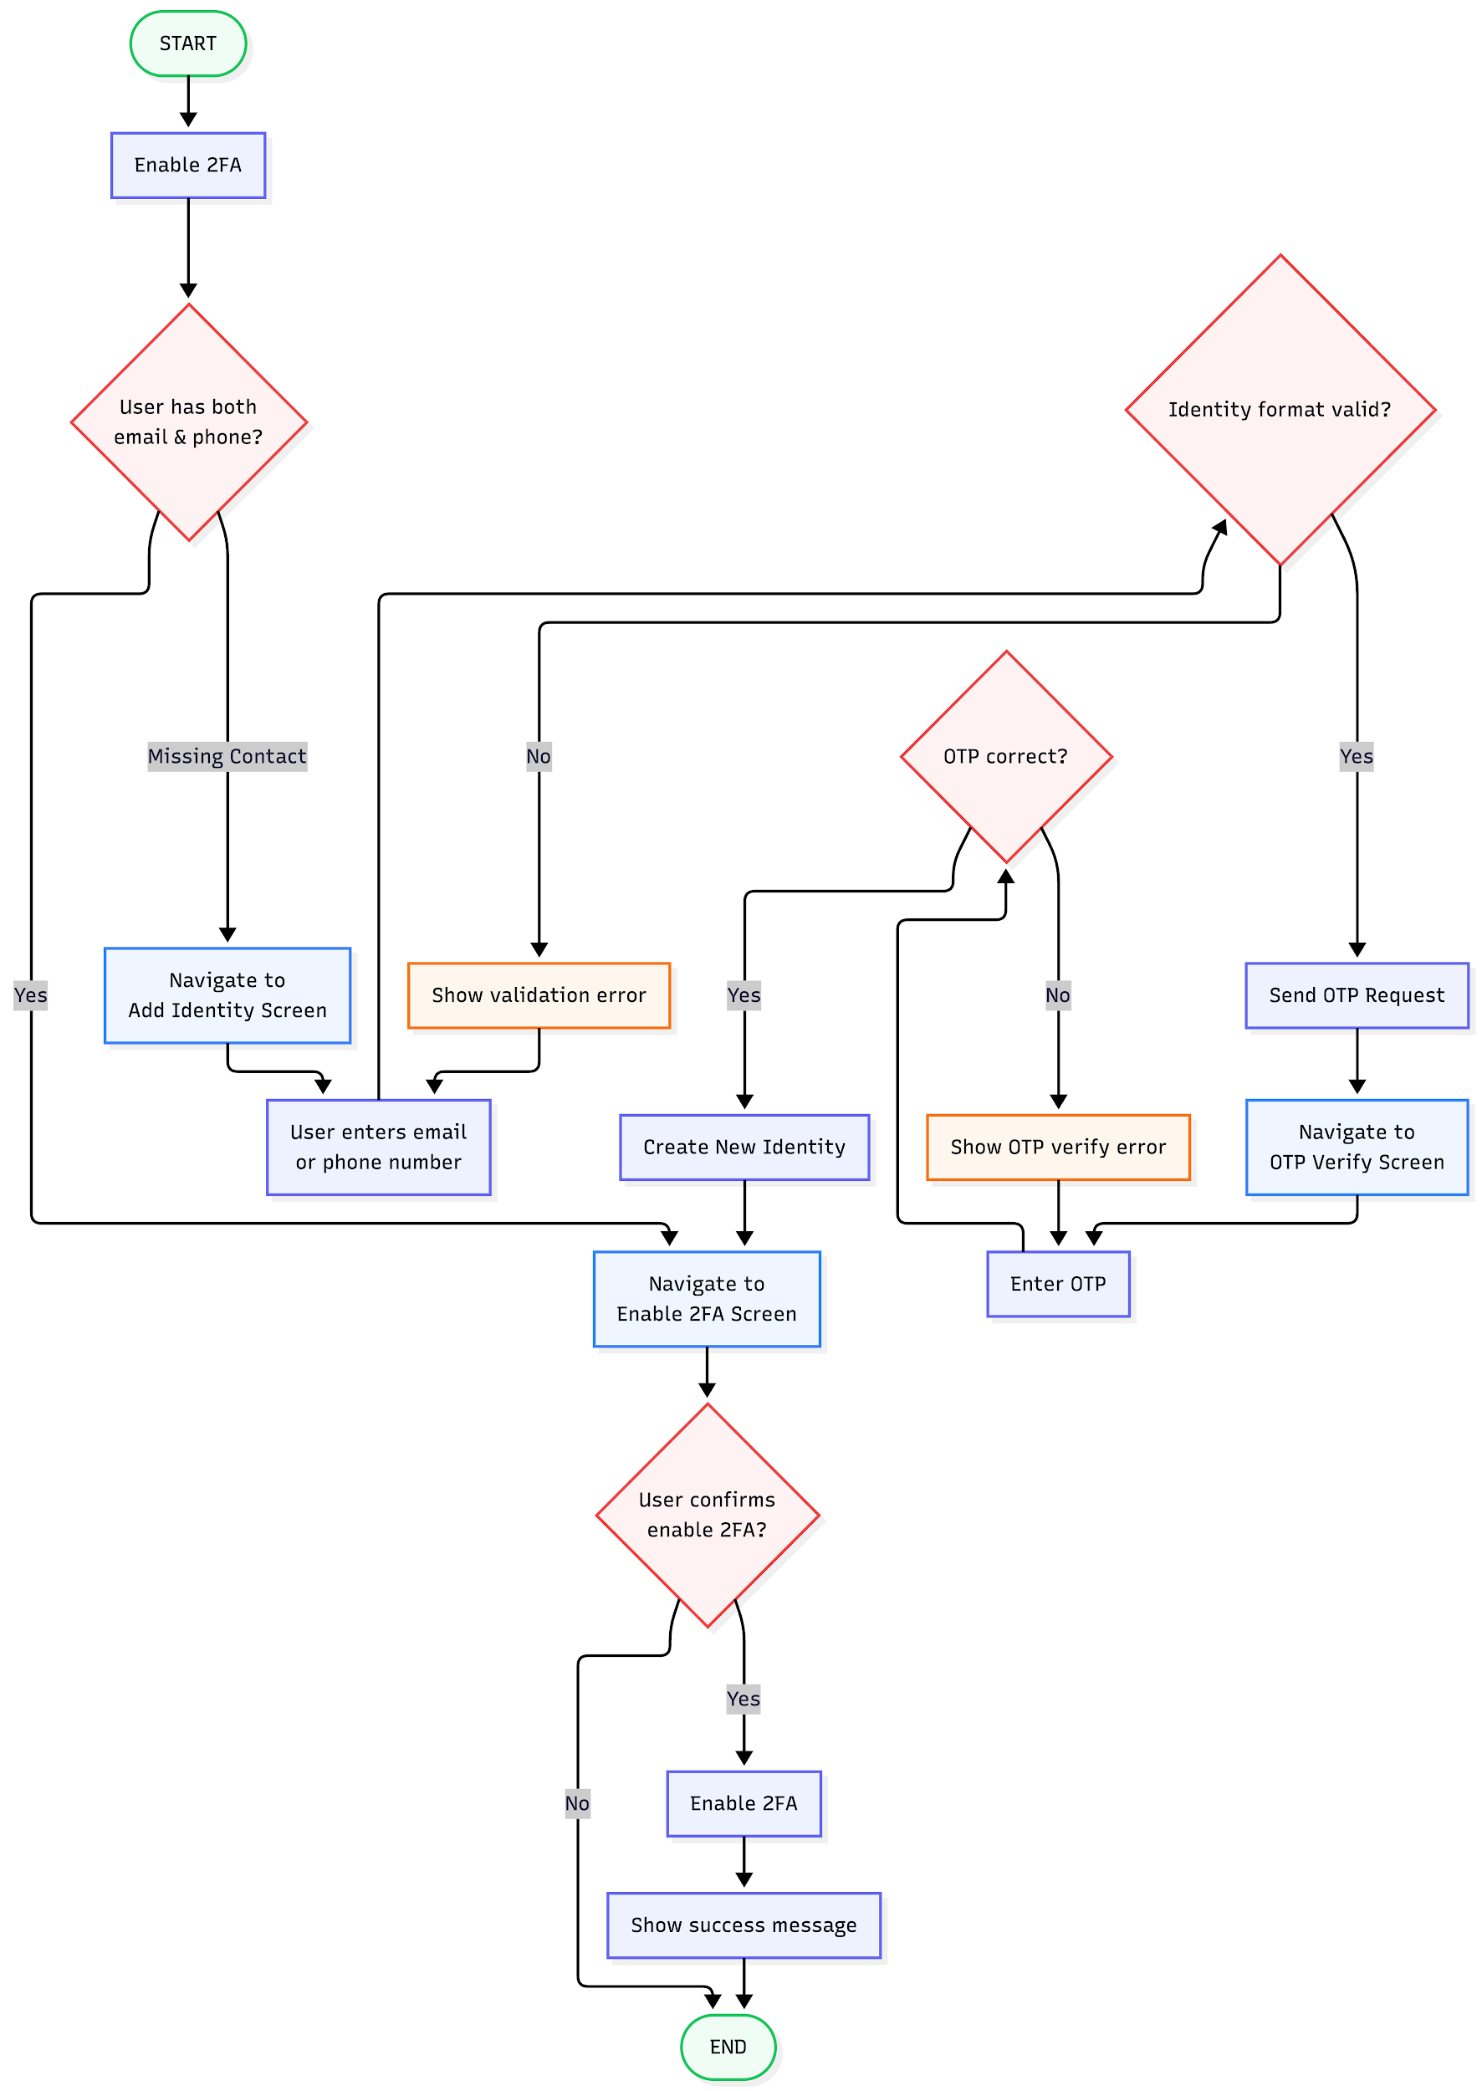

Sequence Diagram
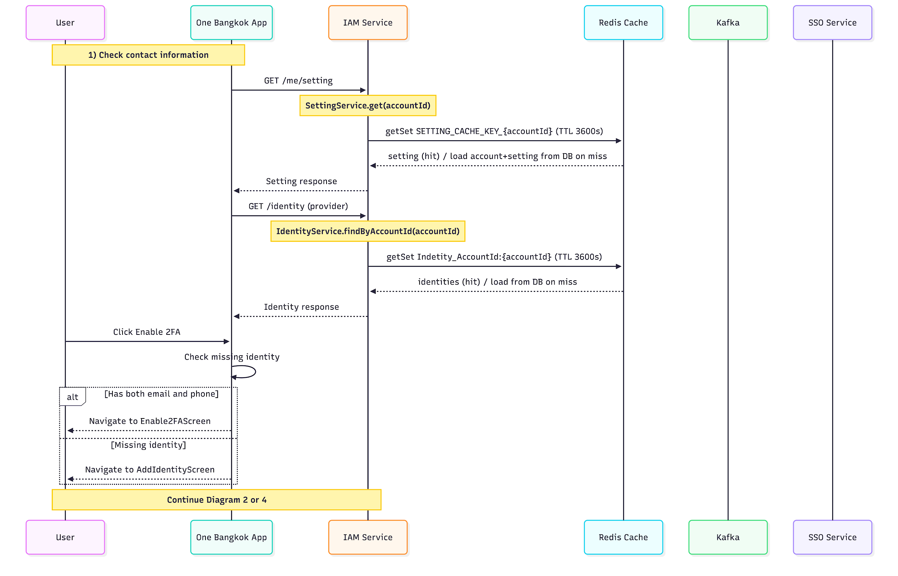
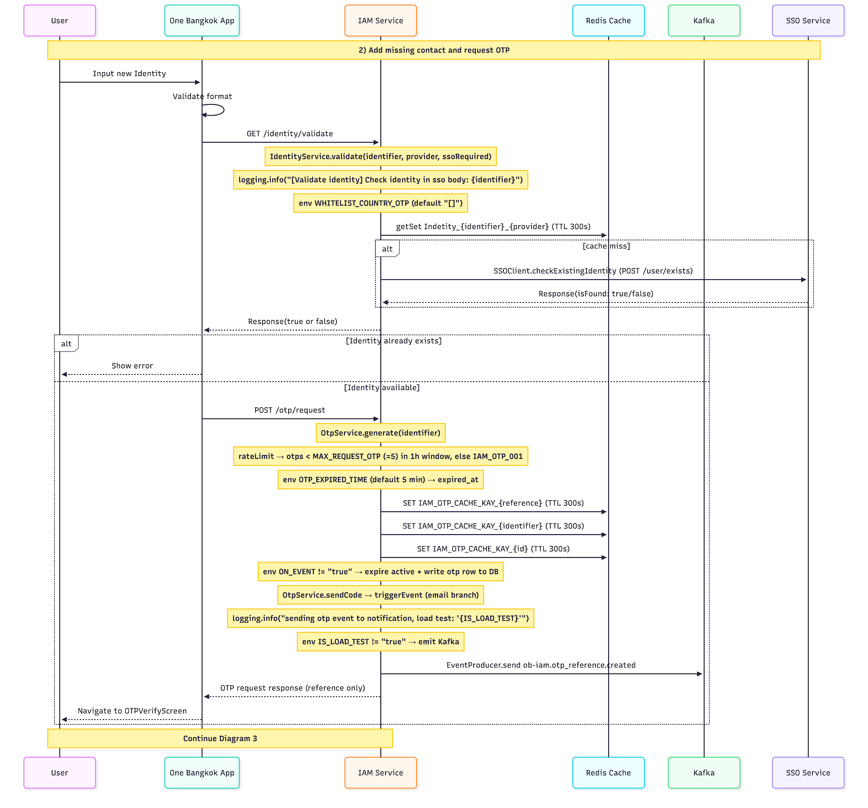
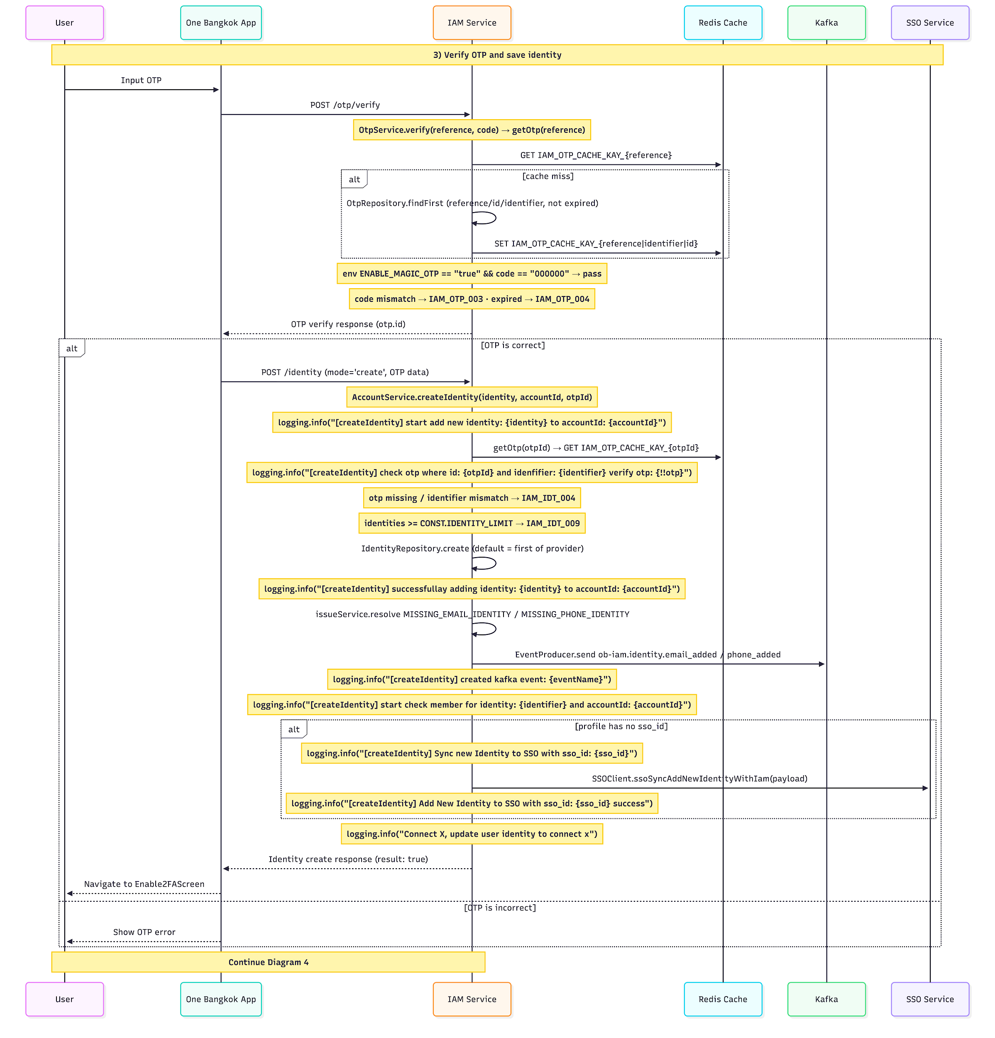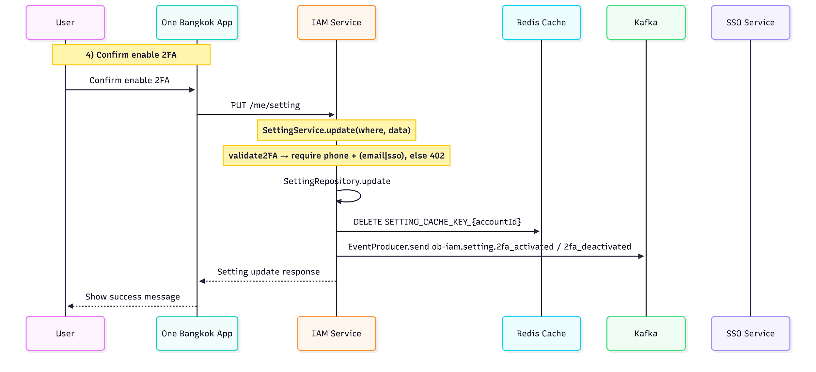

Setting Index API Description

Overview
- Method: GET
- Path: /me/setting
- OperationId: setting.index
- Description: Get current account setting values.

Request

Header Parameters
Name | Type | Required | Description
x-account-id | string | true | Account ID of the current user

Request Example
GET /me/setting HTTP/1.1
x-account-id: 6bb2d7b2-f924-4b7b-b322-5df7db3d63f8

Success Response

HTTP 200
Field | Type | Description
two_factor_authentication_enabled | boolean | Whether 2FA is enabled
password_enabled | boolean | Whether account has a password set
receive_marketing_email | boolean | Whether user accepts marketing email
receive_marketing_sms | boolean | Whether user accepts marketing SMS
accept_terms_and_conditions | boolean | Whether user accepted terms and conditions
accept_privacy_policy | boolean | Whether user accepted privacy policy
current_language | string | Current language. Supported values: `en`, `th`, `cs`

Success Example
{
"data": {
"setting": {
"two_factor_authentication_enabled": false,
"password_enabled": true,
"receive_marketing_email": false,
"receive_marketing_sms": false,
"accept_terms_and_conditions": true,
"accept_privacy_policy": true,
"current_language": "en"
}
}
}

Error Response

Error Object Format
Field | Type | Description
error.code | string | Application error code
error.message | string | Human-readable error message
error.stack | string | Stack trace (non-production only)

Errors Scenario
HTTP Status | Error Code | Message | Cause
500 | IAM_IDT_003 | Account not found | Setting record was not found for account

Error Example
{
"error": {
"code": "IAM_IDT_003",
"message": "Account not found"
}
}

OTP Request API Description

Overview
- Method: POST
- Path: /otp/request
- OperationId: otp.request
- Description: Generate an OTP reference and send OTP to the provided identity

Request

Body Parameters
Field | Type | Required | Description
identity.provider | string | true | Identity provider. Supported values from API model: `phone`, `email`, `sso`, `keycloak`
identity.identifier | string | true | Target identifier (phone number or email). Input is sanitized with trim + lowercase before processing
identity.country_code | string | false | Country code (example: `+66`). Used for phone validation/normalization

Request Example
{
"identity": {
"provider": "phone",
"identifier": "0812345678",
"country_code": "+66"
}
}

Success Response

HTTP 200
Field | Type | Description
data.otp.reference | string | OTP reference for the next verification step (`/otp/verify`).

Success Example
{
"data": {
"otp": {
"reference": "A1B2C3"
}
}
}

Error Response

Error Object Format
Field | Type | Description
error.code | string | Application error code
error.message | string | Human-readable error message
error.stack | string | Stack trace (non-production only)

Errors Scenario
HTTP Status | Error Code | Message | Cause
429 | IAM_OTP_001 | OTP reach requested limited | OTP request limit exceeded for identifier
403 | IAM_OTP_001 | OTP reach requested limited | OTP request limit exceeded for identifier
403 | IAM_OTP_004 | Invalid Whitelist Country OTP | Phone country code is not in allowed whitelist
500 | IAM_OTP_006 | Invalid Phone Number | Phone number format is invalid
500 | IAM_OTP_007 | Too many OTP requests | Phone cooldown or country rate limit exceeded
500 | IAM_OTP_008 | OTP requests from your country have exceeded the allowed limit | OTP requests from your country have exceeded the allowed limit | Country block limit exceeded

Error Example
{
"error": {
"code": "IAM_OTP_006",
"message": "Invalid Phone Number"
}
}

OTP Verify API Description

Overview
- Method: POST
- Path: /otp/verify
- OperationId: otp.verify
- Description: Verify OTP code by reference and return OTP id when valid.

Request

Body Parameters
Field | Type | Required | Description
otp.reference | string | true | OTP reference received from OTP request endpoint
otp.code | string | true | OTP code entered by user

Request Example
{
"otp": {
"reference": "ABCD1234",
"code": "123456"
}
}

Success Response

HTTP 200
Field | Type | Description
data.otp.id | string | OTP record id after successful verification

Success Example
{
"data": {
"otp": {
"id": "clx1234567890"
}
}
}

Error Response

Error Object Format
Field | Type | Description
error.code | string | Application error code
error.message | string | Human-readable error message
error.stack | string | Stack trace (non-production only)

Errors Scenario
HTTP Status | Error Code | Message | Cause
500 | IAM_OTP_003 | Invalid OTP | OTP reference not found or OTP code does not match
500 | IAM_OTP_004 | OTP Expired | OTP code is expired

Error Example
{
"error": {
"code": "IAM_OTP_003",
"message": "Invalid OTP"
}
}

Setting Update API Document

Overview
- Method: PUT
- Path: /me/setting
- OperationId: setting.update
- Description: Update setting values for the current account

Request

Header Parameters
Name | Type | Required | Description
x-account-id | string | true | Account ID of the current user

Body Parameter
Field | Type | Required | Description
two_factor_authentication_enabled | boolean | false | Enable or disable 2FA. When set to `true`, account must have both phone and email/sso identities
password_enabled | boolean | false | Included in request model but not used by update service logic
current_language | string | false | Preferred language. Supported values: `en`, `th`, `cs`
accept_terms_and_conditions | boolean | false | Terms acceptance flag
accept_privacy_policy | boolean | false | Privacy policy acceptance flag

Request Example
{
"two_factor_authentication_enabled": true,
"current_language": "en",
"accept_terms_and_conditions": true,
"accept_privacy_policy": true
}

Success Response
Field | Type | Description
two_factor_authentication_enabled | boolean | Whether 2FA is enabled
password_enabled | boolean | Whether account has password set
receive_marketing_email | boolean | Whether user accepts marketing email
receive_marketing_sms | boolean | Whether user accepts marketing SMS
accept_terms_and_conditions | boolean | Whether user accepted terms and conditions
accept_privacy_policy | boolean | Whether user accepted privacy policy
current_language | string | Current language value

Current language value
{
"data": {
"setting": {
"two_factor_authentication_enabled": true,
"password_enabled": true,
"receive_marketing_email": false,
"receive_marketing_sms": false,
"accept_terms_and_conditions": true,
"accept_privacy_policy": true,
"current_language": "en"
}
}
}

Error Response

Error Object Format
Field | Type | Description
error.code | string | Application error code
error.message | string | Human-readable error message
error.stack | string | Stack trace (non-production only)

Errors Scenario
HTTP Status | Error Code | Message | Cause
402 | INTERNAL_SERVER_ERROR | Phone Identity doesn't exist | Enabling 2FA without phone identity on account
402 | INTERNAL_SERVER_ERROR | Email Identity doesn't exist | Enabling 2FA without email/sso identity on account
400 | INTERNAL_SERVER_ERROR | setting not found | Setting record not found during update

Error Example
{
"error": {
"code": "INTERNAL_SERVER_ERROR",
"message": "Phone Identity doesn't exist"
}
}

Cache Key
Key | TTL | Source | Purpose
SETTING_CACHE_KEY_{accountId} | 3600s | SettingService.get | Cache account + setting; deleted in SettingService.update.
Indetity_AccountId:{accountId} | 3600s | IdentityService.findByAccountId | Cache the account's identity list (missing-factor check).
Indetity_{identifier}_{provider} | 300s | IdentityService.validate | Cache SSO existence result for an identifier.
IAM_OTP_CACHE_KAY_{reference} | 300s | OtpService.generate / getOtp | OTP record keyed by reference.
IAM_OTP_CACHE_KAY_{identifier} | 300s | OtpService.generate / getOtp | OTP record keyed by identifier.
IAM_OTP_CACHE_KAY_{id} | 300s | OtpService.generate / getOtp | OTP record keyed by OTP UUID (used by createIdentity).

Environment Variables
Variable | Default | Purpose
OTP_EXPIRED_TIME | 5 (minutes) | OTP expiry duration applied to expired_at.
ON_EVENT | — | If true, skips the DB write during OTP generation (cache-only).
IS_LOAD_TEST | — | If true, skips SMS sending and the OTP Kafka event.
ENABLE_MAGIC_OTP | — | If true, OTP code 000000 always passes verification (test/QA).
ENABLE_REGISTRATION_WHITELIST | — | If true, enforces whitelist on /identity/validate and POST /identity.
MIN_APP_VERSION | 1.0.0 | Compared against app-version to decide whether SSO-required validation applies.
WHITELIST_COUNTRY_OTP | [] | JSON array of allowed country calling codes for phone OTP.

